Homework 03/10/21

1. This device can be programmed to carry out general purpose, mathematical and/or logical computations. E.g., a digital computer transit information using digital signals.
2. A programmable computer is a computer that can be modified to do certain tasks.
3. A general purpose machine means that the machine can be used to carry out any general tasks, not one specific task.
4. A pocket calculator is not a computer as it is a machine made for a specific purpose and only carry out a small set of calculations.
5. A signal represents changing information and are used to transmit information from one placed to another.
6. Signals are used in operating digital computers.
7. A digital signal is a signal that is used to represent data as a sequence of discrete values.

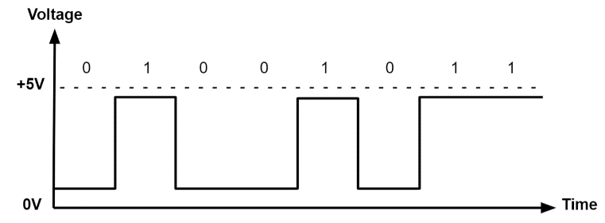e.g.

1. Digital computers are computers that operate using digital signals.
2. An electronic computer is one that operates using electricity.
3. A semiconductor is a special type of material that falls between and electrical conductor and an electrical insulator e.g., silicon.
4. Semiconductors can be designed to be an insulator, a conductor or both – this means that they can be used to control the flow of electrons in a computer.
5. Silicon

* They can carry out any general purpose computations
* They are relatively inexpensive and portable
* They perform well